**NOTICE!** There should be more then 2 users in mobile app (click + to add a new user)

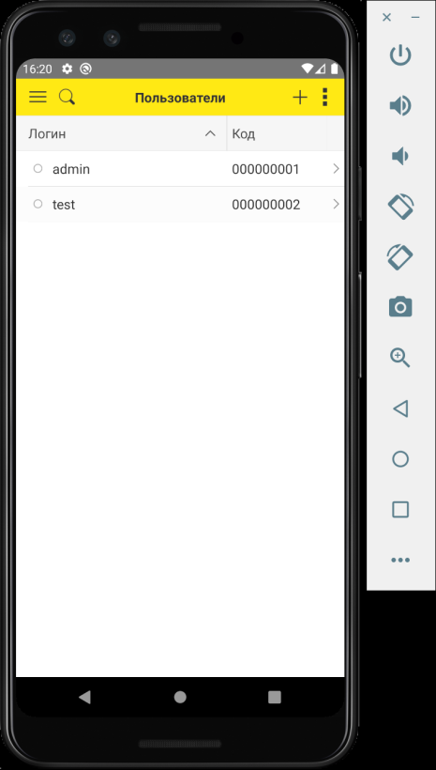

**Role admin**

1. Authorization:

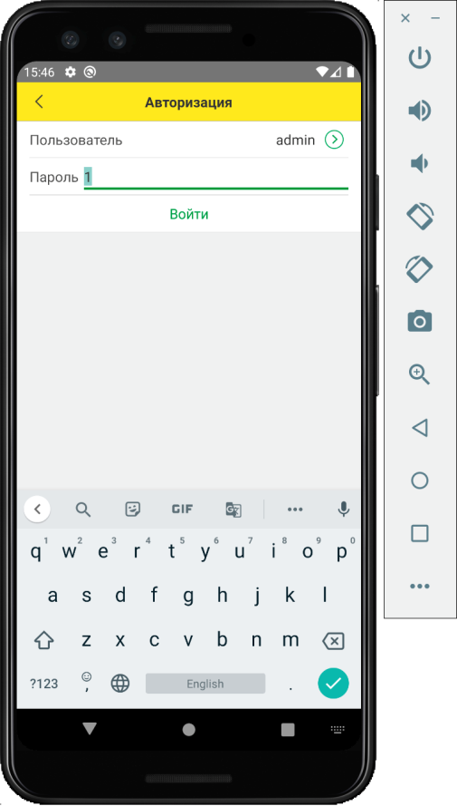

1. Here you see the list of orders and invoices for payment

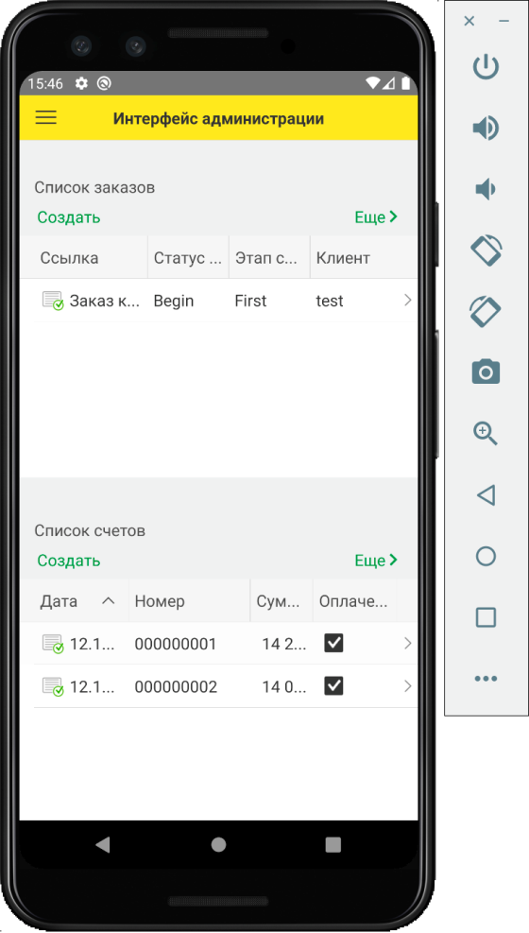

1. To add a new photo in order, admin should click «Add» in list of photos:

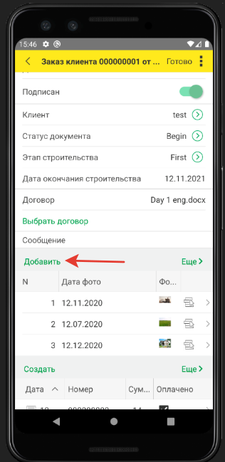

1. Here admin fills the date of photo

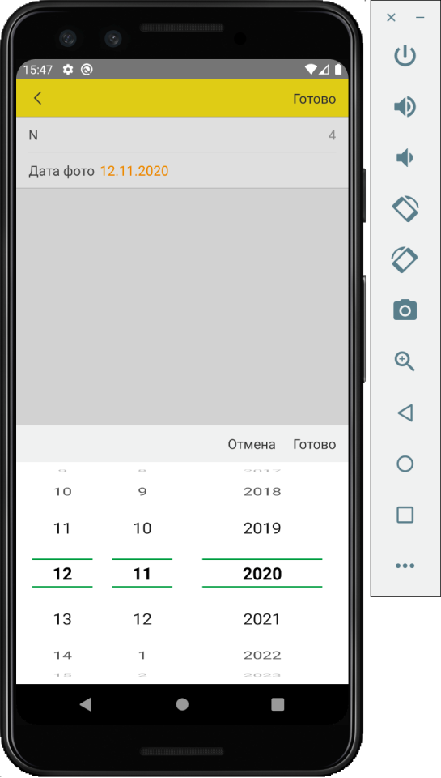

1. By clicking this icon, admin upload photo from device storage

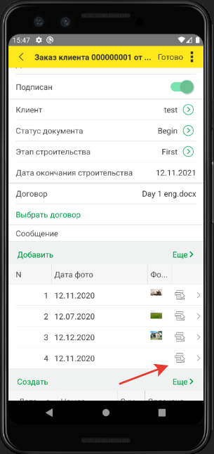

1. Admin choose photo file

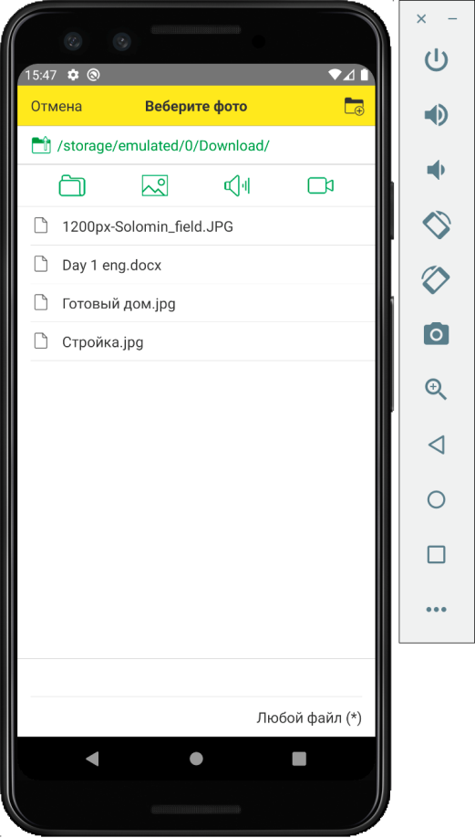

**Role buyer**

1. Start user form consists of: date of ending of the construction, level of the construction, decision of neural network and status of the construction (based on CV algorithms). There 3 fields in order:
   * Этап строительства (level of the construction, chosed by **admin**).
   * Мнение нейронной сети (decision of neural network). Only result of neural network decision.
   * Статус строительства (status of the construction). It is the result, consisting of neural network decision and our app’s clarification.

**! To display the home screen normally, status of the construction should be chosen by admin in order.**

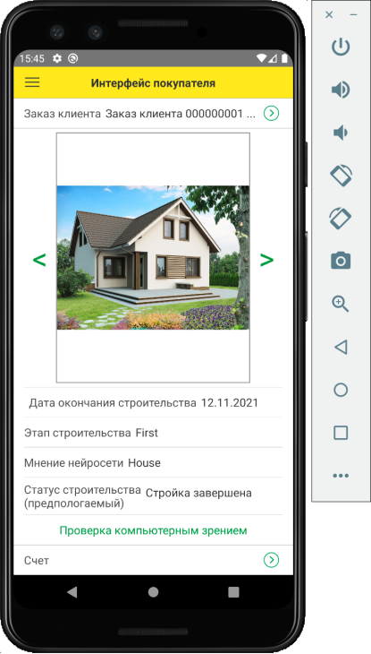

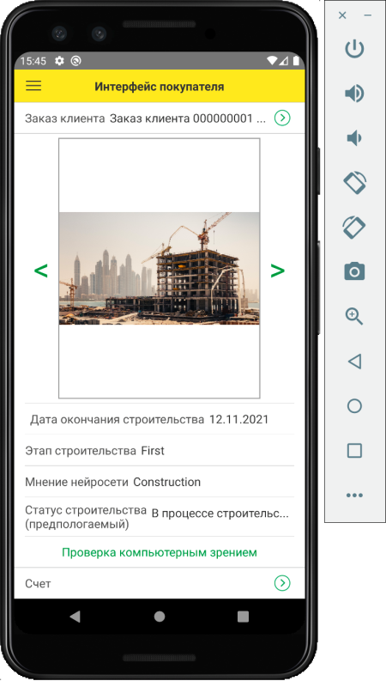

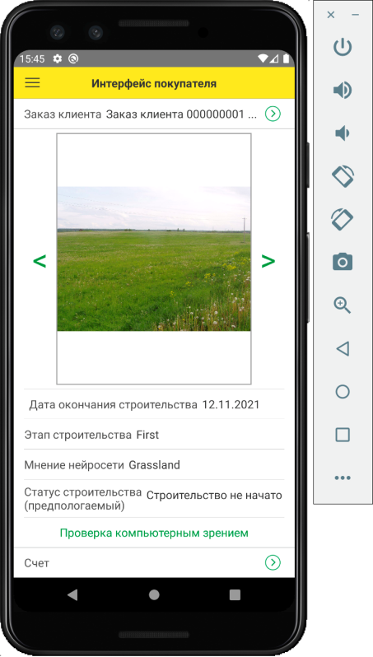

*These 3 photos are result of neural network’s working*

1. There client can pay for order

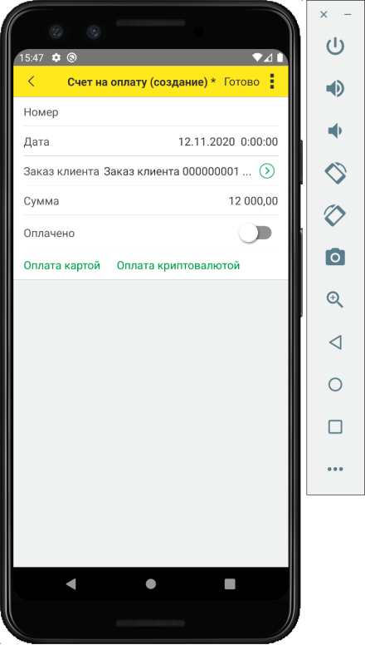

* + if user pay for noncash:

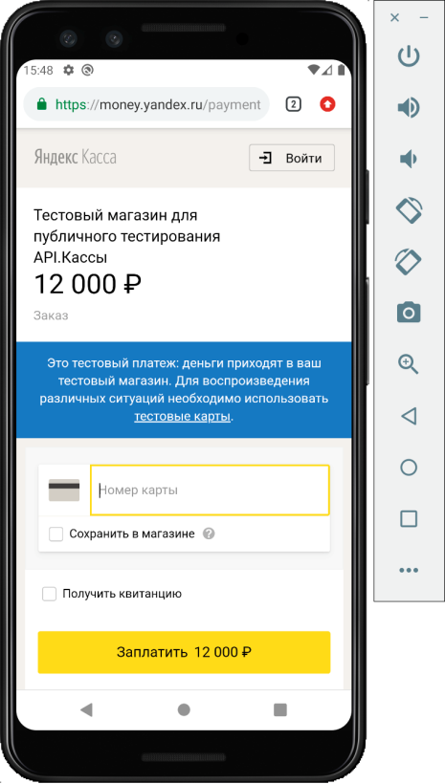

* + if user pay for bitcoin

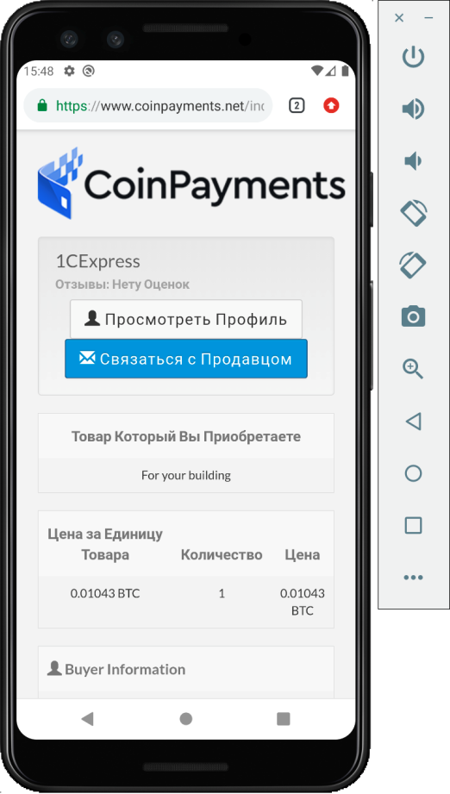

**! Also users can control app by swiping left and right**

